Koszalin University of Technology  ul. Śniadeckich 2  75-453 Koszalin, Poland | 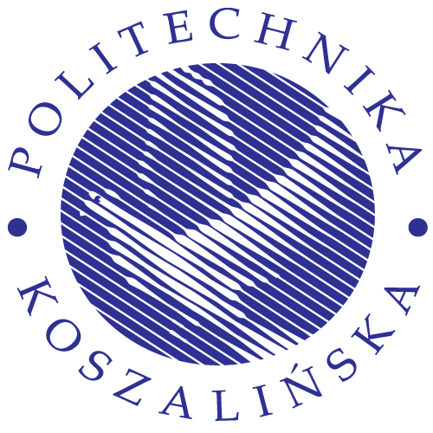

Application Form For International Students
Academic Year | 2 | 0 |  |  | /

1. Course of study
Faculty name: Institute of Technology and Education

Fields of study/program : Materials Science and Engineering

Bachelor

2. Personal details
Sex | Male Female
Surname / Family name | dfghdfh
First names | dfghdfn
Father`s name
Date of birth |  |  |  |  | / |  |  | / |  |  | Country of birth
Citizenship |  |  |  |  |  |  |  |  |  |  | Passport number
Country of permanent residence

Contact address | Home address
Street  Zip code, city  Country  Phone  Fax  E-mail | Street  Zip code, city  Country  Phone  Fax

3. English language competency
Obtained language certificates and dates of exam:

Others:

4. Finance. How do you plan to fund your studies?
I have a scholarship/grant
My family will be funding my studies
Other sources of funding studies

5. Other relevant information | 6. Accommodation
Disability / special needs | Do you wish to book a place in a student hall of residence?
Contact in case of emergency (person/telephone) | Yes No

7. Declaration and Signature
I hereby agree:
– to comply with the rules on admission and enrolment of Koszalin University of Technology (KUT),
– to notify KUT immediately if there is any change to the information I have given on this application,
I understand that:
– the University may obtain official records from any institution I attend previously,
– in this application I must fully declare all studies undertaken, whether complete or incomplete,
– the University may vary or cancel any decision it makes if the information given is incorrect, incomplete or misleading,
– the University will not re-enroll me if I do not complete my studies satisfactorily in each year
– I agree to pay tuition fee, before receiving final admission letter
– I cannot ask the University or the Polish Government to help me if I run short of funds,
– if these documents are false or inaccurate, the University can share information about me and my application to other institutions and the relevant authorities,
– the University may provide information about me to the Polish government legally entitled to receive it,
I am aware of tuition costs and living expenses and have sufficient resources to cover the full period of study.
I declare that the information given in this application is true and correct.

Signature | Date Date | 2 | 0 |  |  | /

Checklist – please make sure that you include the following
application form (signed and dated)  certified copy of Secondary School Certificate (translated into Polish)  legalization of the certificates of secondary education (by a Polish consul in the country, where a document was issued. Go with the document to the Polish Consulate or Polish Embassy and ask about the procedure of the legalization)  nostrification of the certificates of secondary education by Education Office in Szczecin  certified copy of your English proficiency | 4 passport photos  a medical certificate  a copy of the passport  admission fee payment  receipt

Please send complete printed and signed form to:

Koszalin University of Technology
International Relations Office
ul. Śniadeckich 2
75-453 Koszalin
Poland

Contact person:
Mrs. Diana Wojtewicz
Tel. +48 94 34 78 692
e-mail: diana.wojtewicz@tu.koszalin.pl

